1. Grab Monday.com and go to Burghclere vouchers. This is important as you will want to work your way up from RG20 vouchers to RG20 properties then lastly to RG20 customers.

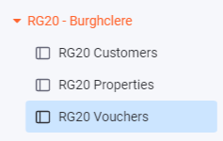

1. Find the customer in RG20 vouchers and fill in necessary information such as email, phone number and address if not already done. Once this is all done then use the three dots on the far left side of the customer account and select move to, then select move to board RG20 customers and press move item, then press move item anyway until it has gone to that board.

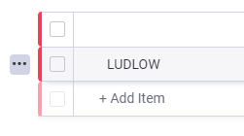

1. For this step you will need to select RG20 properties and find the property you are provisioning. You are then going to want to make sure the fields such as town/city, county and postcode are all filled in correctly. Then copy the location data (coordinates) and paste them into location (the marker should fill in blue when correct) see below with how it should look.

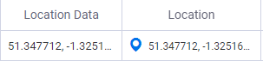

1. The next step will involve you using [https://fibermap.uk.vetro.io/map#18.38/51.348144/-1.325226](https://fibermap.uk.vetro.io/map" \l "18.38/51.348144/-1.325226) to access the properties that are in Burghclere and then grab the access node which can be found by selecting the property you are provisioning. The properties that are needed will have a blue house icon. Then looking at the top left of the screen it will show you the access node that you will need to use. See below image for where to find the access node and what the houses should look like when trying to find them (The access node should start with RG20-).

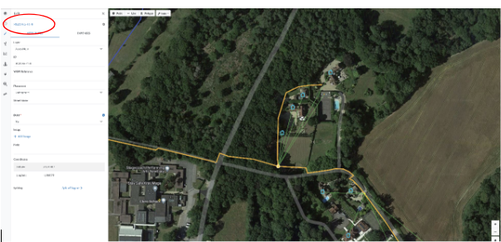

1. Enter this access node into the correct column, then what you will need to do is to sort it by order and this will show you how many other properties are on that access node. Knowing how many other properties are on that access mode will allow you to fill out the connection order column. With the access node column in the correct order you will be able to tell what number property it will be for that access node. As seen below with the access node column ordered correctly you can see that the connection order for those properties going up in increments of 1 per property added.

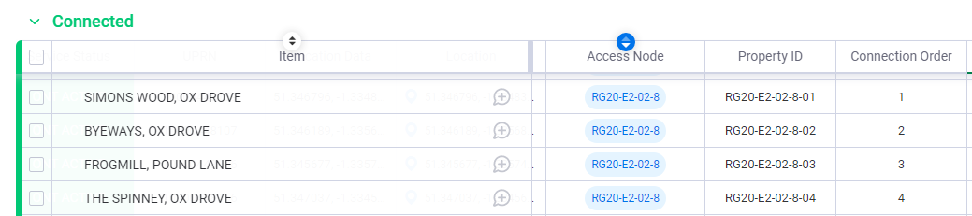

1. The next step would be to grab the F/SAN of the ONT from the installing engineer so that you can fill it out in the FSAN column and the automation knows what ONT to assign for the customer/property.when filling out the FSAN you would need to use the format shown below. You will also need to confirm with the engineer what model ONT it is whether it is an 801, 803 or an 812. Then upload the pictures from the installing engineer to the installation photos column.

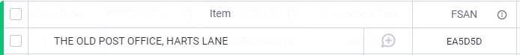

1. Now you will want to select the customers page on and make sure that the customer you have moved from the voucher page. Select that customer and on the column containing the surname there will be a speech bubble icon; select the icon and a page will appear on the right side of the screen. On that page select more and then select subitem templates, on that page select click on select a template then choose onboarding then apply template. Be patient as it can take a few seconds to appear. Then close the chat bubble page with the small x in the left corner.

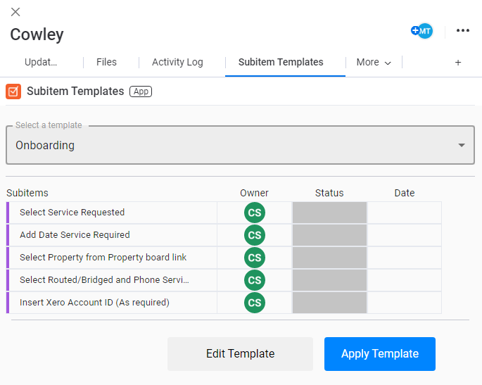

1. From here you will need to then click on the arrow next to the customer surname and it will bring up a checklist of things to check and fill out. Follow this checklist and make sure it is all filled out correctly. For date service required select the date that you are carrying this out. Move along to the RG20 properties section and search for the property you are provisioning. Next step is to fill out the service requested section with the service the customer is requesting. The way to find this would be to use <https://app.pipefy.com/pipes/301582709> and get any extra details about the customer that may be needed.
2. Having completed all the tasks on the checklist it should make the grey bar go green and change the status column to pending. This means you are ready to use the automation. Open <https://eu1.make.com/10243/scenarios/58909/edit> and if not already open then select the scenario below. (it is near the bottom of the list and is the longest name).



1. Once you have selected the above scenario click on the diagram but **DO NOT click any of the circles. You are going to click on run once (bottom left) then listen for new. Once this is done go back to monday.com and change the status column on the customer from pending to verified. Go back to Make.com and verify that the automation has followed the whole way through on the top branch. When it has then that is service provisioned and you can confirm it has worked by checking SMX.**