- You will need to create a Plume account for the customer using an email address you can log into (you will need to set this up on an iPhone Add the Plumes that you will be using to the account (making sure they are updated).
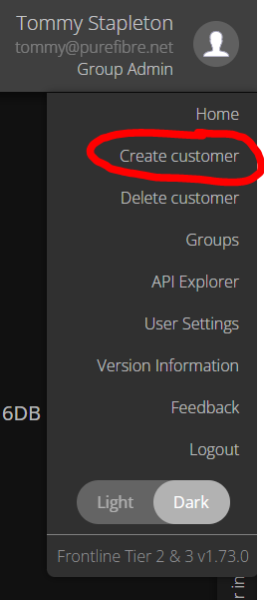
- Run through the VLAN setup process on the Plume app to get the Plumes both online. This can be done in the conference room on the port setup for VLAN 911.
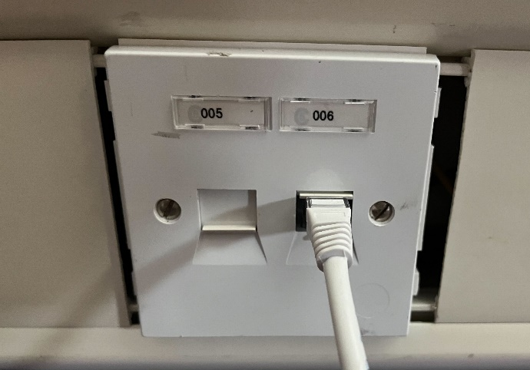

- Once the Plume pods are both online, you will want to change the email address on the Plume account to the one that the customer has provided.
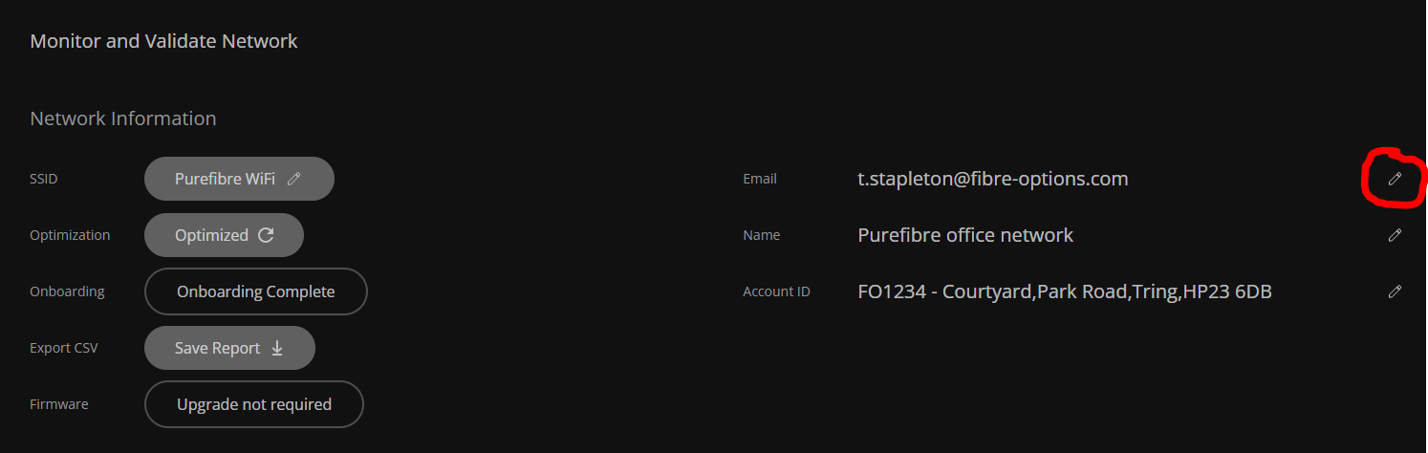

- You will then need to get these Plume pods boxed up with a cat5 cable and label them for the specific customer. These can then be given over to customer services for shipping.
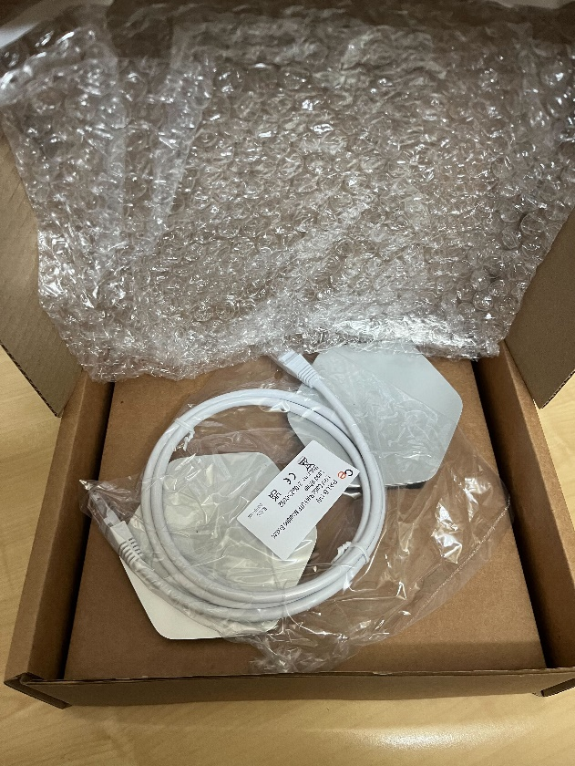
As long as both Plume pods came online while the account setup was being carried out, it will not matter which one acts as the gateway as they will both have picked up the setting and should have updated the firmware if given enough time to reboot.

