When the customer first loads up the app, they will go through the onboarding process which will be a little different to normal. It should start with something like name your network which is normal but then it will move to the step of “setting up… about 2 minutes left”. This will usually take a little longer than 2 minutes so don’t worry if it does.
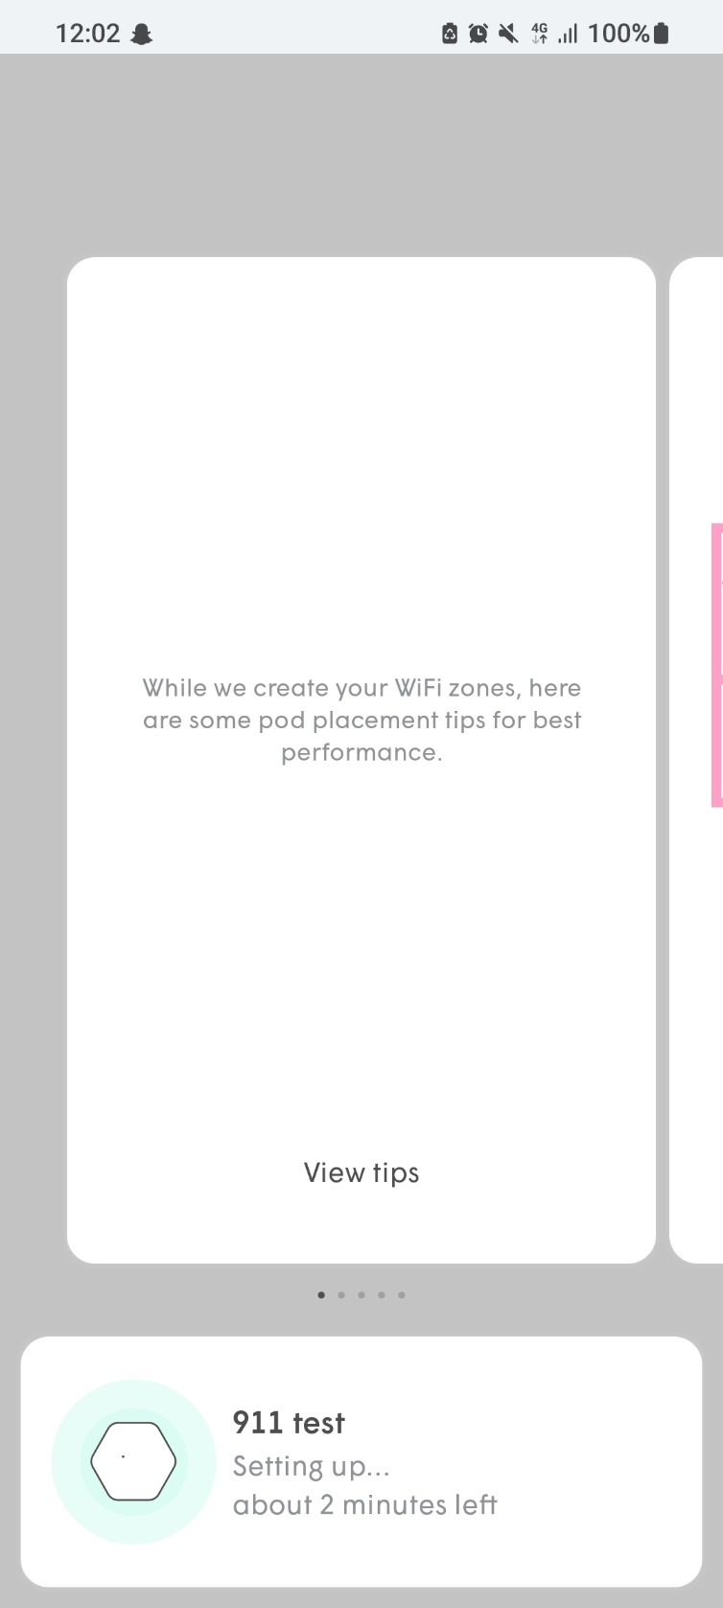

Once this is done then it will move to the next step which is “did you restart the modem?”. When this appears then you will want to power done the ONT for a couple seconds. When this is done then get the customer to press “yep, modem restarted”.
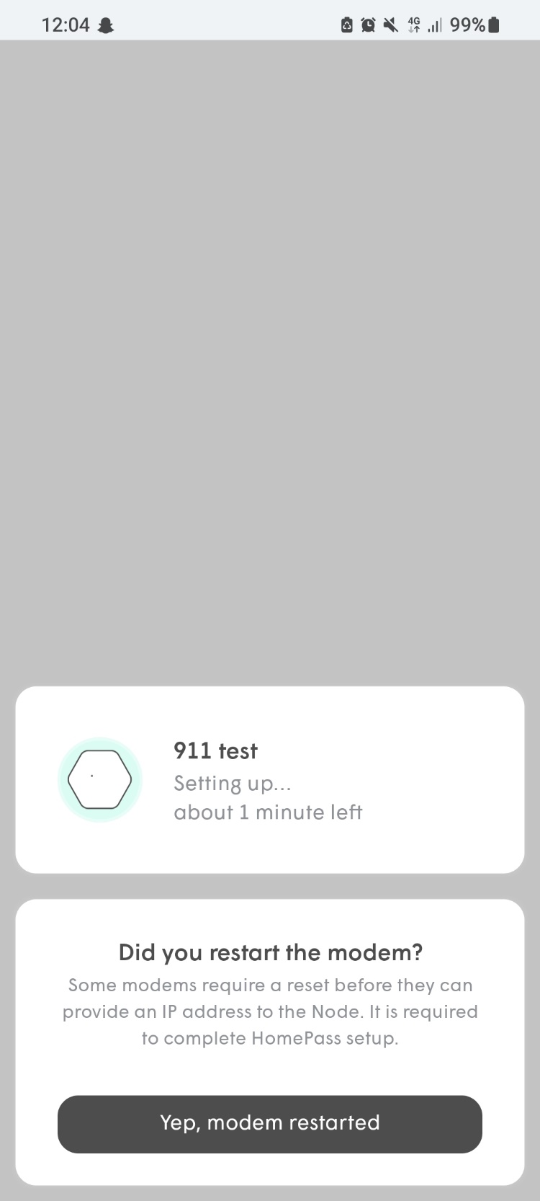

When this is pressed then you will get a screen that says, “we found the pod, but it has no internet”. This screen will also have the option to go into “advanced configuration” which is near the bottom of the screen in a white box. Get the customer to press that.
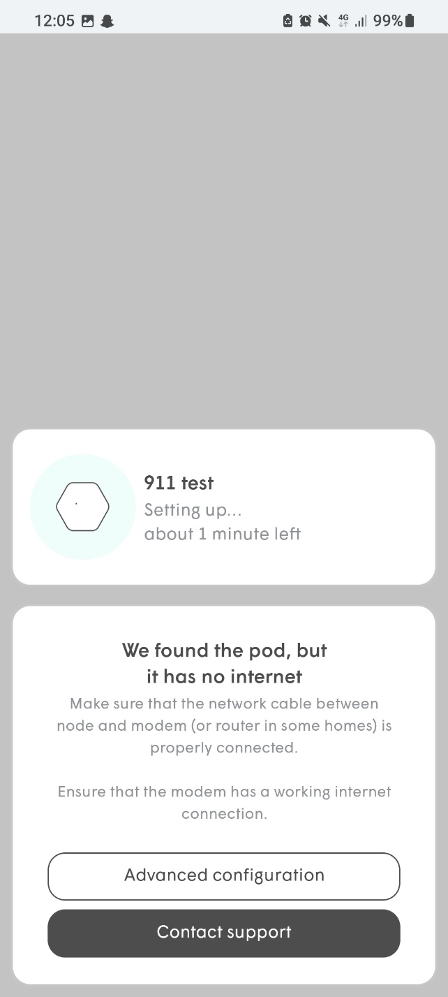

The next page will say “advanced setup” and “looking for pod stay close”. There will be some more text saying, “once you have connected all the pieces, touch the pod connected to the modem with your phone”. This step takes a while so you will have to bear with it while it connects to the pod.

When this has successfully connected it will say “Great. we have found the pod”. This will give the customer the option to go to “advanced setup options”.
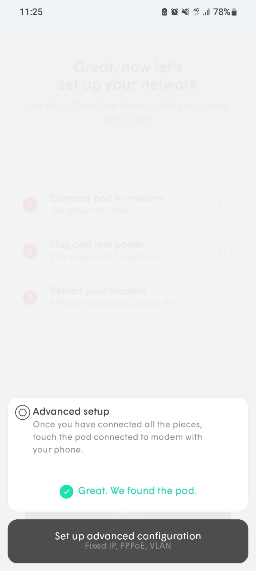

Sometimes it may come up with a page saying still looking for pod. If so, then it may be worth unplugging the Plume and the ONT (small black Cityfibre box) for 10 seconds then plug it in.
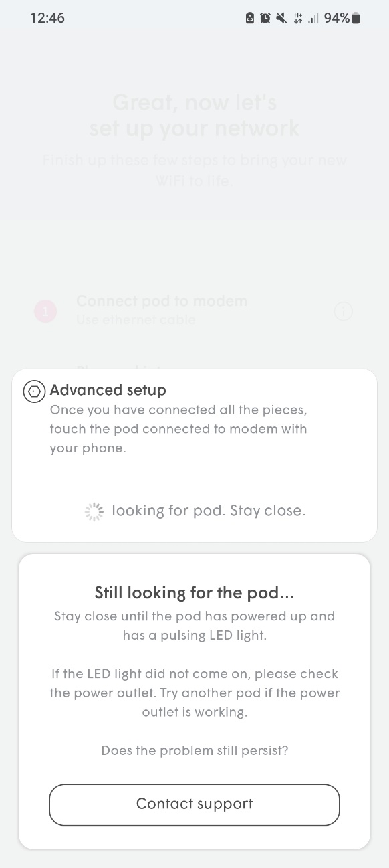

This page has 3 options, and you will want the customer to select the “VLAN” option which will come up with a text box underneath a title. The title is “WAN VLAN”.

When the text box option has been selected then the customer will want to enter “911” then select “set”. Then the customer will want to select “save”.

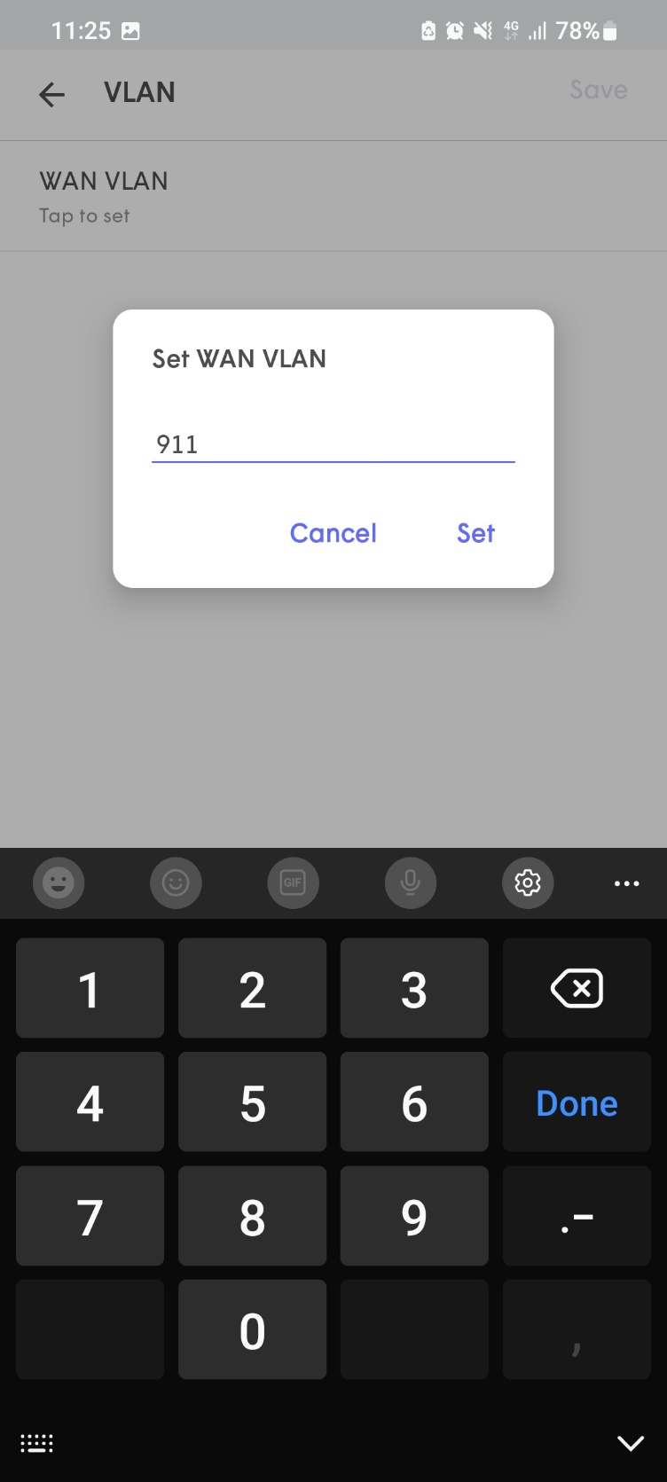

Upon entering the VLAN correctly, the customer will be prompted to pair with Bluetooth to the pod which the customer will want to accept to finalise the process of setting the VLAN. This stage will finalise with “Pairing. This could take up to 2 mins.” This is the final step and should end with the pod having the VLAN set and taking the customer to the home page.

