1.Verify that you have the correct customer information such as email, address and subscriber ID
2.Locate the “Plume customers” board on the “customer workspace” on Monday.com.
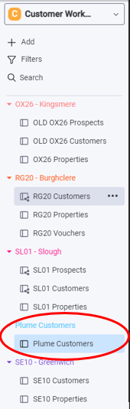
3. Fill in the necessary information in the correct fields such as name, address, email and subscriber ID as the automation will not work without these items.
4. Open Make.com, open and search for “Plume upgrade customers” and press run once, then it will have an option for “listen for new” select that. Once pressed go the Monday board again and change the send welcome email column to send email.
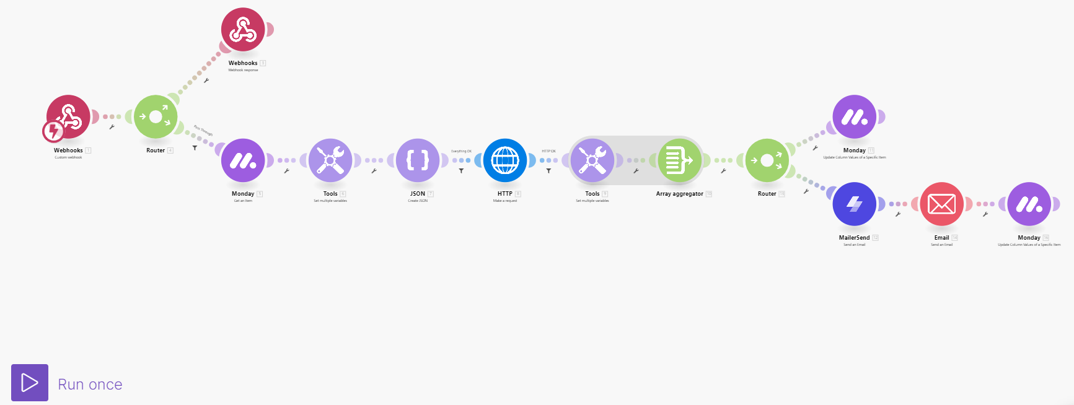
5. Having changed the status to send email the automation will start; you will be able to watch as it completes.
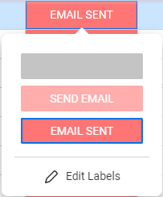
6. this step is only if you encounter an error. If an error is encountered with the automation, then the key things that will need to be checked are:
- Information is properly filled in like name and address
- The email being used by another account
- The customer’s account is verified

7. To fix the issue with the Plume page as seen below and change to verified.
